LAB EXERCISE 7
CODE INJECTION ON APPLICATION PROCESS USING PTRACE

AIM
To study and perform code injection on a running application process using the ptrace system call in Kali Linux for understanding process control and debugging mechanisms.

SOFTWARE / TOOLS REQUIRED
Kali Linux
GCC compiler
Root privileges (sudo)
ptrace (Linux system call)

PROCEDURE
Step 1: Create a Target Program

This program runs continuously so it can be attached to.
// target.c
#include <stdio.h>
#include <unistd.h>

int main() {
while (1) {
printf("Target process running...\n");
sleep(2);
}
return 0;
}

Compile and run:

gcc target.c -o target
./target
Step 2: Find Process ID

Open a new terminal and find the PID.

ps aux | grep target

Example:

root 2456 0.0 ./target

PID = 2456

Step 3: Create Ptrace Injection Program

This program attaches to the target and modifies its instruction pointer (RIP).

// inject.c
#include <sys/ptrace.h>
#include <sys/wait.h>
#include <sys/user.h>
#include <stdio.h>
#include <stdlib.h>

int main(int argc, char *argv[]) {
if (argc != 2) {
printf("Usage: %s <pid>\n", argv[0]);
return 1;
}

pid_t pid = atoi(argv[1]);
struct user_regs_struct regs;

ptrace(PTRACE_ATTACH, pid, NULL, NULL);
wait(NULL);

ptrace(PTRACE_GETREGS, pid, NULL, &regs);
printf("Original RIP: %llx\n", regs.rip);

regs.rip += 2; // simple instruction pointer modification
ptrace(PTRACE_SETREGS, pid, NULL, &regs);

ptrace(PTRACE_DETACH, pid, NULL, NULL);
return 0;
}

Compile:

gcc inject.c -o inject
Step 4: Execute Injection

Run with root privileges:

sudo ./inject 2456

The injector attaches, modifies execution flow, and detaches.
OUTPUT
Injector successfully attaches to the target process.
Instruction pointer (RIP) is modified.
Target process execution behavior changes momentarily.
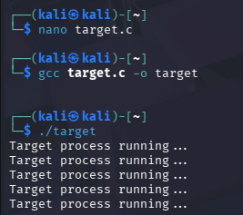
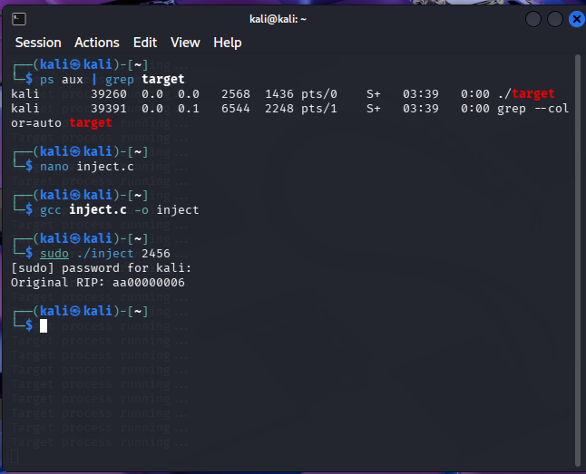

RESULT
Thus, code injection using ptrace was successfully performed on a running application process in Kali Linux.
This experiment demonstrates process tracing, register manipulation, and runtime control using the ptrace system call.

